Differential growth and pigmentation responses to photic regimes in phycoerythrin(PE)-rich and phycocyanin(PC)-rich picocyanobacteria

Sylwia Śliwińska-Wilczewska1,2, Marta Konik3,4, Naaman Omar1, Mireille Savoie1, Maximilian Berthold1, and Douglas A. Campbell1,✉

1 Department of Biology, Mount Allison University, 53 York St., Sackville NB, Canada, E4L 1C9  
2 Institute of Oceanography, University of Gdansk, 46 Pilsudskiego St, P81-378, Gdynia, Poland  
3 Department of Geography, University of Victoria, Victoria, BC V8P 5C2, Canada  
4 Institute of Oceanology, Polish Academy of Sciences, 81-712 Sopot, Poland

✉ Correspondence: [Douglas A. Campbell <[dcampbel@mta.ca](mailto:dcampbel@mta.ca)>](mailto:dcampbel@mta.ca)

# Abstract

Picocyanobacteria are the most abundant phytoplankters in the aquatic ecosystems and play a crucial role in the optical properties of ocean water, influencing its color and transparency. However, their physiological response to photic regimes remains insufficiently recognized. Our aim was to determine whether various strains of *Synechococcus* respond differentially to light levels and photoperiods. Two phycoerythrin(PE)-rich and two phycocyanin(PC)-rich strains of *Synechococcus* were grown under photoperiods of 8, 12, 16, and 24 h, and 30, 90, 180, 300, and 900 µmol photons m-2s-1. Using high frequency measurements, we found the strains showed faster logistic growth rates with increasing light and photoperiod, although some strains suffered photoinhibition of growth under 900 µmol photons m-2s-1 and 24 h photoperiod. The shortest time to reach daily maximum absolute growth was under 300 µmol photons m-2s-1 and 24 h photoperiod for all strains. Using whole-cell absorbance spectra we showed that the PE-rich strains always had a higher Photosynthetically Usable Radiation(PUR)/Photosynthetically Active Radiation(PAR) ratio than did the PC-rich strains. In general, the PUR/PAR ratio decreased with increasing light, while for PC-rich strains, the PUR/PAR ratio initially increased under low light and short photoperiod. We also observed an increase in cell-specific pigment content during initial growth, followed by a sharp decrease. These patterns occurred after strains reached their daily maximum absolute growth. Our results show the PE-rich strains are stronger light harvesting competitors, but the PC-rich strains may have lower N-quotients for their light capture system. These differences may help explain differential seasonal prevalence of PE-rich and PC-rich picocyanobacteria, in terms of costs of exploitation of different photic regimes.

# Introduction

The availability of light, both its intensity (irradiance) and the length of its presence in the environment (photoperiod), play a pivotal role in influencing the growth and productivity of phytoplankton within aquatic ecosystems. In polar regions, characterized by prolonged periods of darkness during winter and continuous daylight during summer, phytoplankton encounter unique challenges. The limited light availability in winter restricts their growth and metabolic activity, whereas the extended daylight in summer allows for intense photosynthetic activity, resulting in the bloom formations (Arrigo, 2014). In temperate regions, where the photoperiod varies seasonally, phytoplankton respond to these fluctuations in light availability. Spring and summer, with longer daylight hours, provide favorable conditions for phytoplankton growth and heightened productivity. Conversely, reduced light availability in fall and winter constrains their metabolic rates and growth (Huisman et al., 2013). At the equator, where day length remains relatively constant throughout the year, light availability remains consistently high. This uninterrupted illumination sustains photosynthetic activity and supports relatively elevated phytoplankton productivity (Behrenfeld et al., 2006). While other factors, such as temperature, nutrient availability, and mixing dynamics, also impact phytoplankton growth in all regions, comprehending the role of light availability is essential for elucidating the spatial and temporal variability of phytoplankton communities within aquatic environments. Such insights are crucial for assessing ecosystem dynamics, predicting responses to climate change, and understanding variability in light regimes.

The optical properties of seawater are influenced not only by phytoplankton biomass, but also by its composition and physiological state (Babin et al., 2003; Falkowski et al., 2008). Spectral absorption and scattering properties exhibited by phytoplankton significantly contribute to the overall light field within the ocean, thereby impacting underwater visibility and light penetration (Morel, 1974). Picocyanobacteria represent the dominant fraction of phytoplankton in marine environments, and modeling data suggest that their abundance is projected to rise due to climate change (Flombaum et al., 2013). Consequently, it becomes imperative to study changes in the growth and pigmentation of picocyanobacteria in different photic regimes in the context of their impact on changes in the optical properties of oceanic waters. Such studies provide valuable information for assessing the state of the ecosystem and formulating responses to climate change (Méléder et al., 2019). Moreover, studying the optical properties of oceanic waters in relation to shifts in picocyanobacteria abundance enables a deeper understanding of the intricate connections between biological processes, light availability, and the functioning of marine ecosystems (Morel, 1988).

*Synechococcus*, a ubiquitous and abundant genus of picocyanobacteria, assumes a crucial role in aquatic ecosystems owing to its wide distribution and ecological contributions. Functioning as a primary producer, *Synechococcus* actively participates in the global carbon cycle through oxygenic photosynthesis, carbon dioxide fixation, and organic matter generation (Campbell and Vaulot, 1993). Its adaptive capacity to thrive across diverse marine and freshwater habitats positions it as a pivotal agent in energy and nutrient transfer within food webs. Furthermore, *Synechococcus* serves as a link connecting the microbial loop with higher trophic levels, offering direct sustenance to grazers, including zooplankton and small fish (Li, 1995). Consequently, *Synechococcus* assumes an indispensable role in establishing the foundation of aquatic food webs and affects the functioning of entire ecosystems.

Picocyanobacteria are the dominant phytoplankters in oceanic waters, significantly contributing to the primary productivity in the area. In addition, picocyanobacteria *Synechococcus* exerts an influence on the optical properties of water, impacting light attenuation, water transparency, and the availability of light for other photosynthetic organisms (Morel, 1991). Therefore, our aim was to determine whether various strains of *Synechococcus* respond differentially to light levels and photoperiods. Understanding the distribution, abundance, and ecological role of *Synechococcus* becomes imperative for elucidating the intricate dynamics and functioning of aquatic ecosystems, particularly in response to environmental changes.

# Material and Methods

## Culture condition and experimental setup

Two phycoerythrin(PE)-rich (BA048 or BA127) and two phycocyanin(PC)-rich (BA056 or BA077) strains of *Synechococcus*, isolated from the Baltic Sea coastal waters were obtained from Culture Collection of Baltic Algae (CCBA; <https://ccba.ug.edu.pl/pages/en/home.php>).

Strains were grown in MultiCultivator (PSI) in white light under photoperiods of 8, 12, 16, and 24 h, and 30, 90, 180, 300, and 900 µmol photons m-2s-1. Before the experiments, picocyanobacteria strains were kept in 50-mL Erlenmeyer flasks in an incubator with constant light conditions of 30 µmol photons m-2s-1 and photoperiod of 12 h and were transferred to fresh f/2 media (Guillard, 1975) at salinity of 8 psu every two weeks.

## The growth curve, growth rate and number of cells measurements

The picocyanobacterial growth was monitored every 5 minutes by recording optical density at 680 and 720 nm for two weeks with the exception of experiments conducted at 24 h photoperiod or the highest light (900 µmol photons m-2s-1). For these conditions the experiments lasted 7 or 5 days, respectively (Figure 1).

Based on the obtained measurements of the growth curve we determined the logistic growth rate as well as daily maximum growth, periodicity, and slope coefficients of the growth curve for individual strains and given conditions. We also measured the whole-cell absorbance spectra of *Synechococcus* sp. cultures based on which we were able to determine changes in the composition of their photosynthetic pigments: (Chl *a*), carotenoids (Car), phycoerythrin (PE), phycocyanin (PC), allophycocyanin (APC) as well as the changes in PUR/PAR ratio over time.

## Calculation of daily maximum absolute growth, periodicity, and slope coefficients

## Whole-cell absorbance spectra measurements

Absorbance measurements on intact cells in suspension were conducted in an Olis-modernized Cary 14 UV/Vis/NIR with Integrating Sphere upgrade spectrophotometer (On-Line Instrument Systems, Inc., Bogart, GA, USA) according to the method described by Blake and Griff (2012) (Blake and Griff, 2012) with modifications. In an experiment, identical 8 mL solutions that contained f/2 medium, were added to both the sample and reference observation cavities of the spectrophotometer. After recording a baseline from 375 to 710 nm, 1 mL were withdrawn from the sample cavity and replaced with 1 mL of the cell suspension of tested picocyanobacteria. The pathlength corrected absorbance per cm was performed by determining the Javorfi coefficients as described in the equipment manual.

## Photosynthetically Useable Radiation (PUR) calculations

## Measurements of picocyanobacterial cell size

## Pigment content analysis

## Statistical analysis

All analysis of obtained results was conducted using R version 4.3.0 (**rcoreteamLanguageEnvironmentStatistical2019?**) running under RStudio (**rstudioteamRStudioIntegratedDevelopment2015?**), using packages “tidyverse” (Wickham, 2022), “glue” (Hester and Bryan, 2022), “googlesheets4” (Bryan, 2022), “kableExtra” (Zhu, 2021). To determine significant differences in studied experiments the “stats” (**R-stats?**) packages were used. This package provides basic statistical functions, including the aov() function for ANOVA and TukeyHSD() function for Tukey’s test. To conduct the statistical analysis, the two-way ANOVA was performed. If the ANOVA reveals that there are differences among groups, the post-hoc Tukey HDS test was conducted to study which groups are statistically different. Levels of significant difference were: * *p* < 0.05; ** *p* < 0.01; *** *p* < 0.001. Figures were prepared using “ggplot” (**wickhamDataAnalysis2016?**) R package and CorelDraw 11.0 softwere (Corel Corporation, Alludo HQ, Ottawa, Canada).

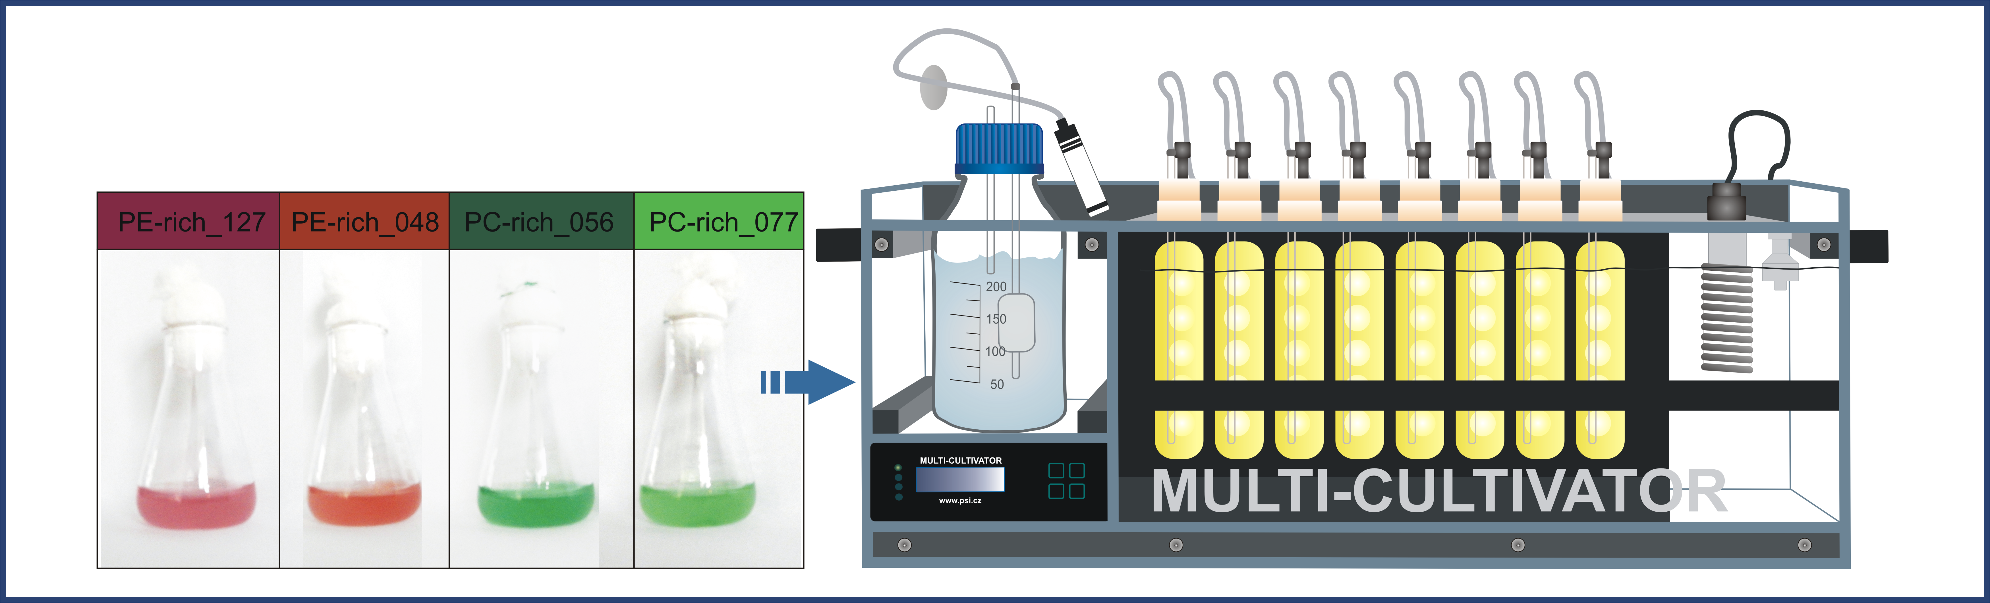

Figure 1: Scheme of the Multi-Cultivator MC257 showing the setup of the experiment and the method of calculating daily maximum absolute growth for cultures of *Synechococcus*.

# Results

Using high frequency measurements we found the strains showed faster logistic growth rates with increasing light and photoperiod, although some strains suffered photoinhibition of growth under 900 µmol photons m-2s-1 and 24 h photoperiod. The shortest time to reach daily maximum absolute growth was under 300 µmol photons m-2s-1 and 24 h photoperiod for all strains.

Strains showed faster logistic growth rates and different daily maximum absolute growth with increasing light and photoperiod, although some strains suffered photoinhibition of growth under 900 µE and 24 h photoperiod (Figure 2; 3).

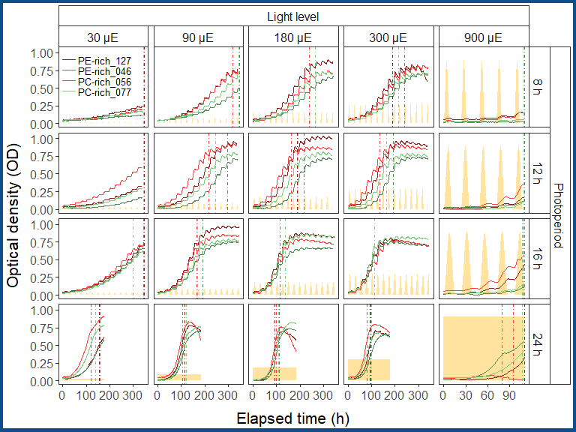

Figure 2: Growth curve (tracked as OD680) of two PE-rich cultures (BA127, BA48) or two PC-rich cultures (BA56, BA77) of *Synechococcus* sp. grown at five light levels (30, 90, 180, 300, and 900 µE) and four photoperiods (8, 12, 16, and 24 h). The vertical lines represent the time when the strains reached their daily maximum absolute growth. The yellow area represents the light intensity for a given day.

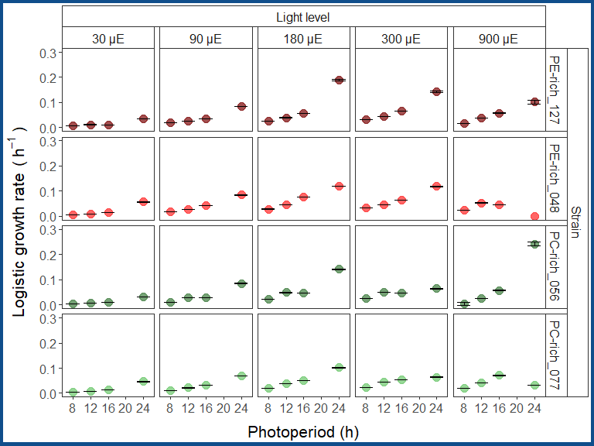

Figure 3: Logistic growth rate (tracked as chlorophyll proxy of OD680-OD720 or using cell-scatter proxy OD720) of two PE-rich cultures (BA127, BA48) or two PC-rich cultures (BA56, BA77) of *Synechococcus* sp. grown at five light levels (30, 90, 180, 300, and 900 µE) and four photoperiods (8, 12, 16, and 24 h). Error bars display the standard error of the logistic growth rate estimated of individual cultures.

Using whole-cell absorbance spectra (Figure 4) we showed that the PE-rich strains always had a higher PUR/PAR ratio, for white light, than did the PC-rich strains. In general, the PUR/PAR ratio decreased with increasing light, while for PC-rich strains, the PUR/PAR ratio initially increased under low light and short photoperiod (Figure 5).

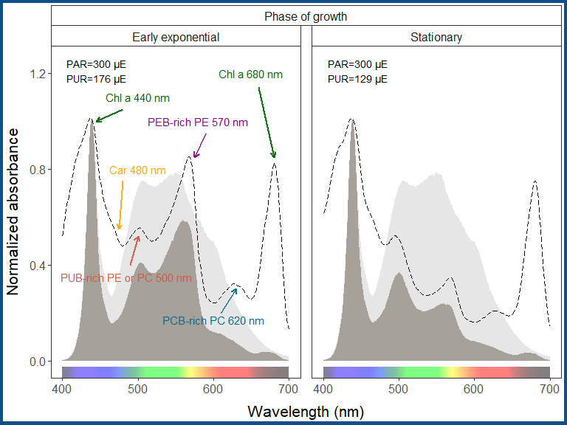

Figure 4: Example of representative whole-cell absorbance spectra normalized to 440 nm of cultures of *Synechococcus* sp. measured on the early exponential and stationary phase of growth, together with emission spectra (light gray area) of the white LED lamps used for their growth and calculated PUR area (dark gray area) for a given day.

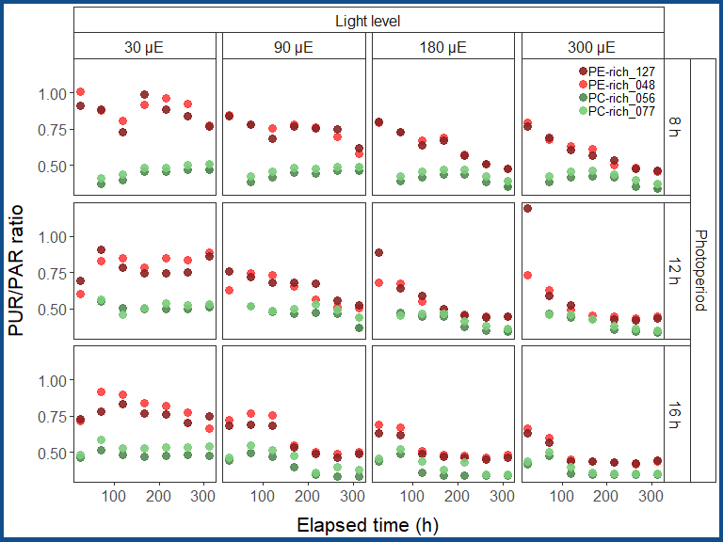

Figure 5: Changes of PUR/PAR ratio of two PE-rich cultures (BA127, BA48) or two PC-rich cultures (BA56, BA77) of *Synechococcus* sp. grown at four light levels (30, 90, 180, and 300 µE) and three photoperiods (8, 12, and 16 h) over time.

PE-rich and PC-rich strains have different cell sizes (Figure 6). We also observed an increase in cell-specific pigment content during initial growth, followed by a sharp decrease. These patterns varied with days of growth, light level, and photoperiod (Figure 7; 8).

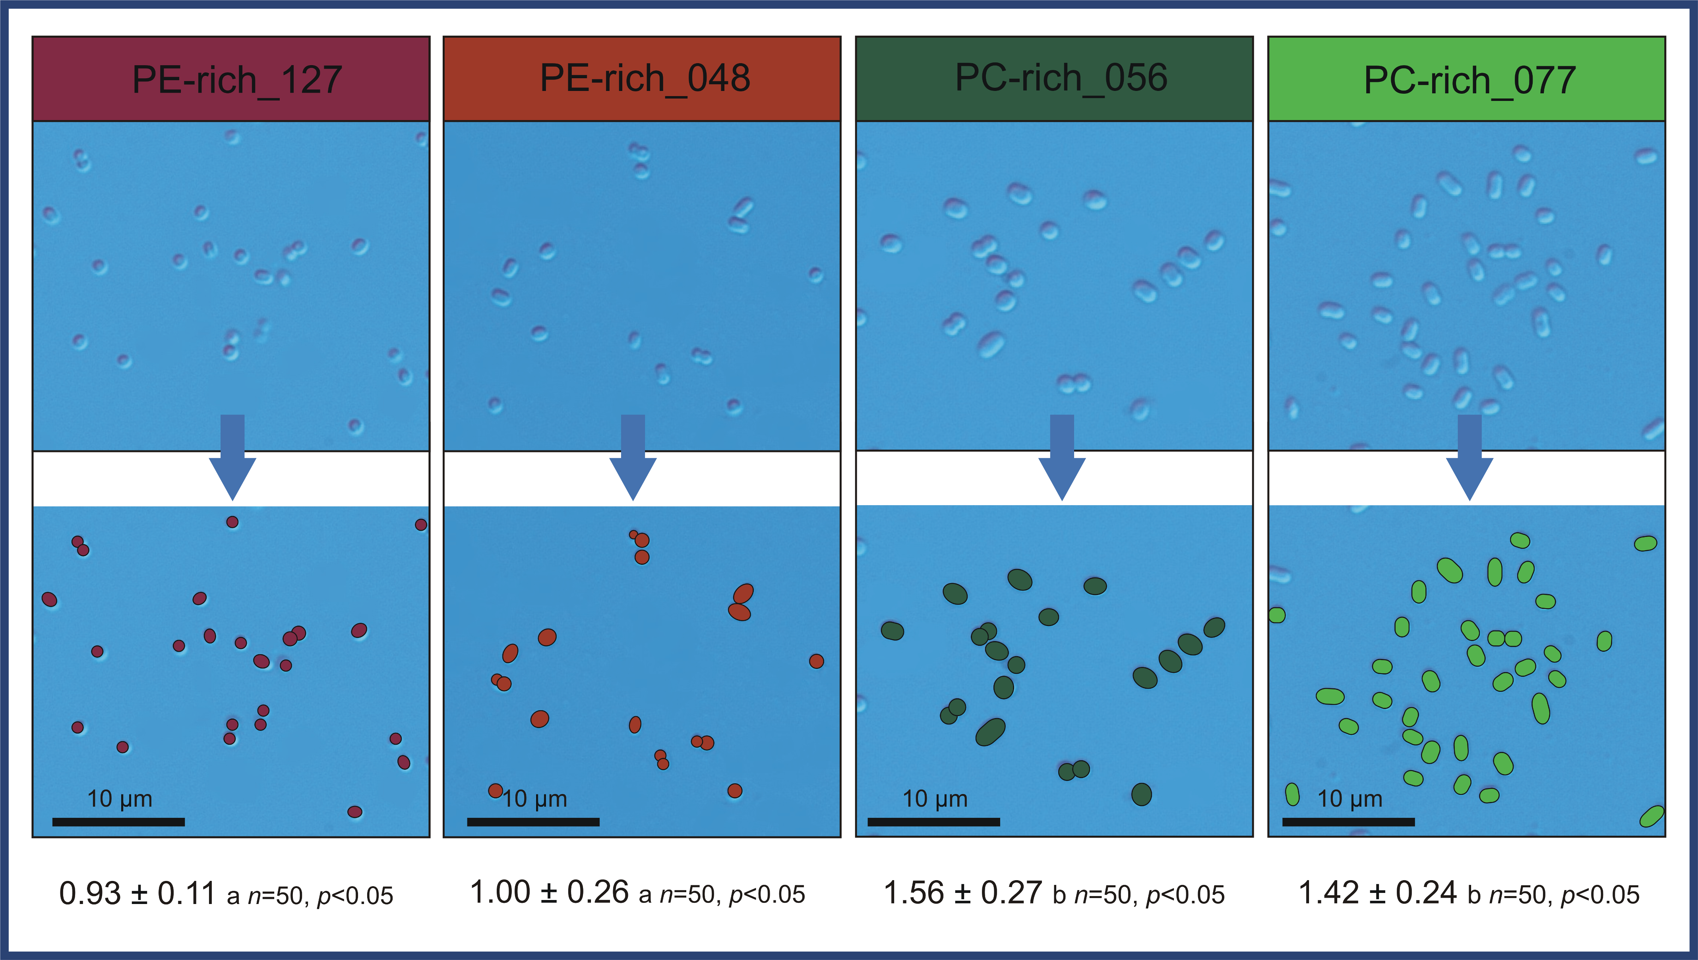

Figure 6: Calculated cell size of Baltic PE-rich (BA127, BA48) or PC-rich (Ba56, BA77) *Synechococcus* sp. strains obtained from light microscope. Bar denotes 10 μm. Different lowercase letters indicate significant differences between the means of the cell size for a given strain (*n*=50, *p*<0.05, two-way ANOVA; Tukey’s HSD test).

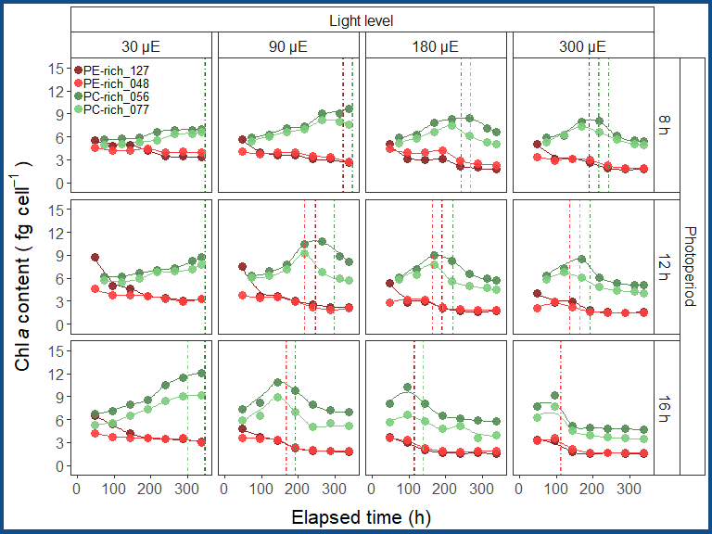

Figure 7: Cell-specific chlorophyll *a* content of two PE-rich cultures (BA127, BA48) or two PC-rich cultures (BA56, BA77) of *Synechococcus* sp. grown at four light levels (30, 90, 180, and 300 µE) and three photoperiods (8, 12, and 16 h) measured on different time (h) of the experiment. The vertical lines represent the time when the strains reached their daily maximum absolute growth.

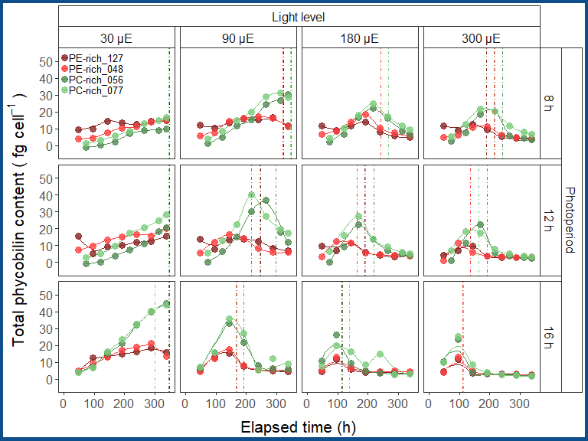

Figure 8: Cell-specific phycobilin content of two PE-rich cultures (BA127, BA48) or two PC-rich cultures (BA56, BA77) of *Synechococcus* sp. grown at four light levels (30, 90, 180, and 300 µE) and three photoperiods (8, 12, and 16 h) measured on different time (h) of the experiment. The vertical lines represent the time when the strains reached their daily maximum absolute growth.

According to Fig. /(**ref?**)(fig:SolisenseData)

# Discusion

Generally, the strains showed faster logistic growth rates with increasing light and photoperiod, although some strains suffered photoinhibition of growth under 900 µmol photons m-2s-1 and 24 h photoperiod. The daily maximum absolute growth was reached the earliest in 300 µmol photons m-2s-1 and 24 h photoperiod for all strains.

Using whole-cell absorbance spectra, we showed that the PE-rich strains always had a higher PUR/PAR ratio than the PC-rich strains.

The PUR/PAR ratio decreased with increasing light in the PE-rich strains, while it initially increased under low light and short photoperiod in the PC-rich strains. We also observed an increase in cell-specific pigment content during the initial growth, followed by a sharp decrease. These patterns varied with days of growth, light level, and photoperiod and occurred always after reaching daily maximum absolute growth.

# Conclusion

Our results show the PE-rich strains are stronger light harvesting competitors, but the PC-rich strains may have lower N-quotients for their light capture system. These differences may help explain differential seasonal prevalences of coastal picocyanobacteria, in terms of costs of exploitation of different photic regimes.

Our results showed the PE-rich strains are stronger light-harvesting competitors as they tend to live deeper in the water column, but the PC-rich strains may have lower N-quotients for their light capture system. These differences may help explain differential seasonal prevalences of coastal picocyanobacteria, in terms of the costs of exploitation of different photic regimes.

# References

Blake, R., Griff, M., 2012. In situ spectroscopy on intact Leptospirillum ferrooxidans reveals that reduced cytochrome 579 is an obligatory intermediate in the aerobic iron respiratory chain. Frontiers in Microbiology 3.

Bryan, J., 2022. googlesheets4: Access google sheets using the sheets API V4.

Hester, J., Bryan, J., 2022. Glue: Interpreted string literals.

Wickham, H., 2022. Tidyverse: Easily install and load the tidyverse.

Zhu, H., 2021. kableExtra: Construct complex table with kable and pipe syntax.